PRACTICAL NO - 02

AIM: Password encryption and decryption:
Use cryptTool to encrypt passwords using the RC4 algorithm
Decrypt the encrypted password and verify the original values

RC4 Encryption Algorithm
RC4 is a stream cipher and variable-length key algorithm. This algorithm encrypts one byte at a time (or larger units at a time). A key input is a pseudorandom bit generator that produces a stream 8-bit number that is unpredictable without knowledge of the input key, The output of the generator is called key-stream, and is combined one byte at a time with the plaintext stream cipher using X-OR operation.
Example:
RC4 Encryption:
10011000 ? 01010000 = 11001000
RC4 Decryption:
11001000 ? 01010000 = 10011000
Key-Generation Algorithm
A variable-length key from 1 to 256 bytes is used to initialize a 256-byte state vector S, with elements S[0] to S[255]. For encryption and decryption, a byte k is generated from S by selecting one of the 255 entries in a systematic fashion, then the entries in S are permuted again.
Key-Scheduling Algorithm
Initialization:
The entries of S are set equal to the values from 0 to 255 in ascending order, and a temporary vector T, is created. If the length of the key k is 256 bytes, then k is assigned to T. Otherwise, for a key with length (k-len) bytes, the first k-len elements of T as copied from K, and then K is repeated as many times as necessary to fill T.

Features of the RC4 Encryption Algorithm :
- Symmetric key algorithm: RC4 is a symmetric key encryption algorithm, which means that the same key is used for encryption and decryption.
- Stream cipher algorithm: RC4 is a stream cipher algorithm, which means that it encrypts and decrypts data one byte at a time. It generates a key stream of pseudorandom bits that are XORed with the plaintext to produce the ciphertext.
- Variable key size: RC4 supports variable key sizes, from 40 bits to 2048 bits, making it flexible for different security requirements.
- Fast and efficient: RC4 is a fast and efficient encryption algorithm that is suitable for low-power devices and applications that require high-speed data transmission.
- Widely used: RC4 has been widely used in various applications, including wireless networks, secure sockets layer (SSL), virtual private networks (VPN), and file encryption.
- Vulnerabilities: RC4 has several vulnerabilities, including a bias in the first few bytes of the keystream, which can be exploited to recover the key. As a result, RC4 is no longer recommended for use in new applications.

Advantages :
- Fast and efficient: RC4 is a very fast and efficient encryption algorithm, which makes it suitable for use in applications where speed and efficiency are critical.
- Simple to implement: RC4 is a relatively simple algorithm to implement, which means that it can be easily implemented in software or hardware.
- Variable key size: RC4 supports variable key sizes, which makes it flexible and adaptable for different security requirements.
- Widely used: RC4 has been widely used in various applications, including wireless networks, secure sockets layer (SSL), virtual private networks (VPN), and file encryption.

Disadvantages :
- Vulnerabilities: RC4 has several known vulnerabilities that make it unsuitable for new applications. For example, there is a bias in the first few bytes of the keystream, which can be exploited to recover the key.
- Security weaknesses: RC4 has some inherent weaknesses in its design, which make it less secure than other encryption algorithms, such as AES or ChaCha20.
- Limited key length: The maximum key length for RC4 is 2048 bits, which may not be sufficient for some applications that require stronger encryption.
- Not recommended for new applications: Due to its vulnerabilities and weaknesses, RC4 is no longer recommended for use in new applications.

Installation :
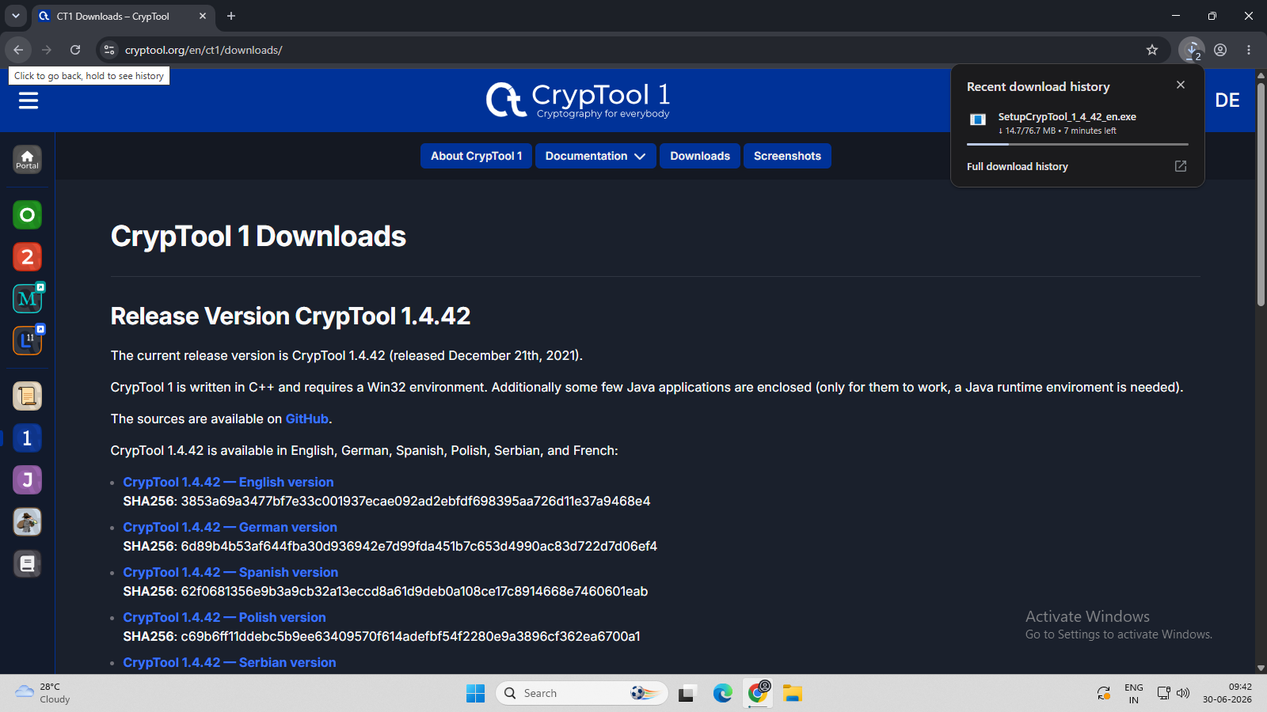
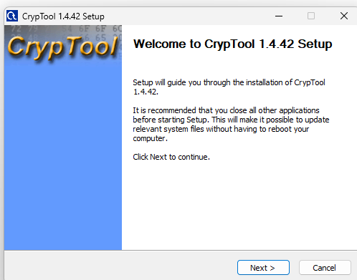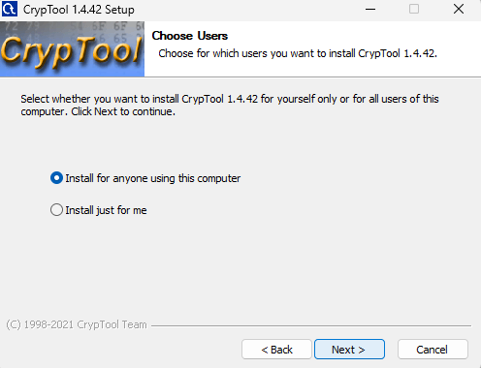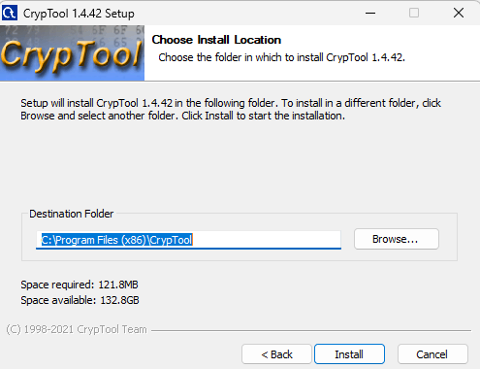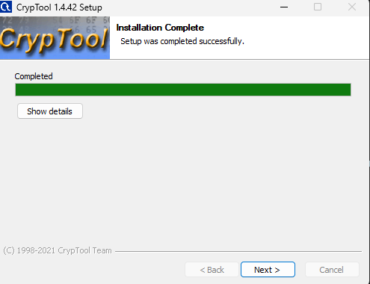
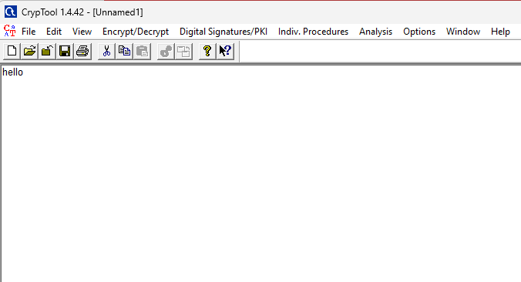
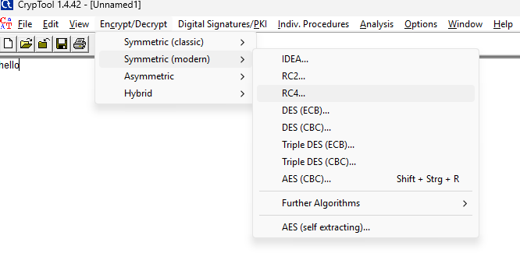
Encryption:
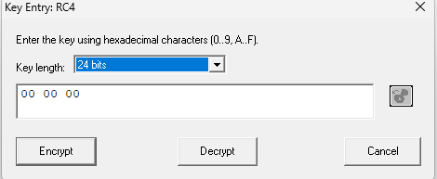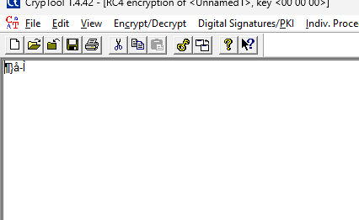

Decryption:
